**Setting up Application Environment**

**Install IBM Cloud CLI**

|  |  |
| --- | --- |
| **Team ID** | PNT2022TMID36945 |
| **Project Name** | Inventory Management Sysytem |
| **Date** | 21 October 2022 |

**Step 1:** First login with **cloud.ibm.com.**

Next search with Container Registry in IBM search catalog

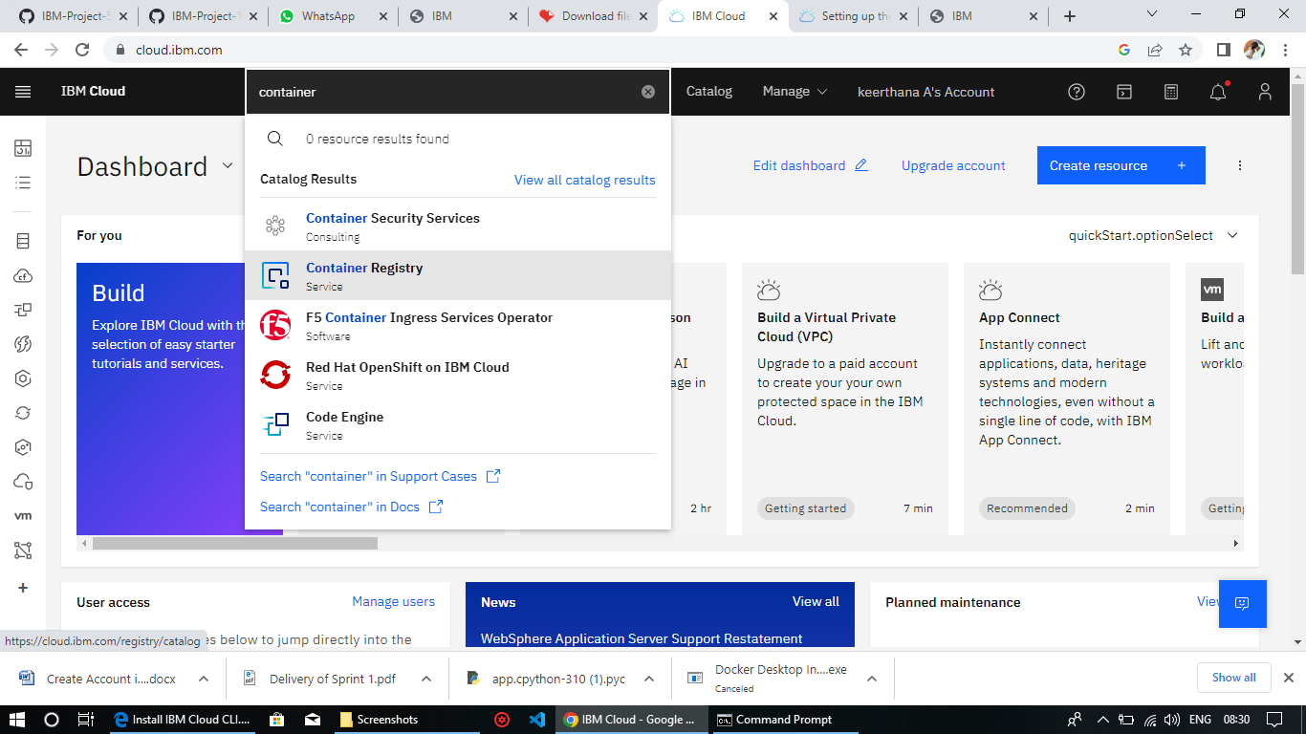

**Step 2:** Next click Get started button Next click Install the IBM Cloud CLI.

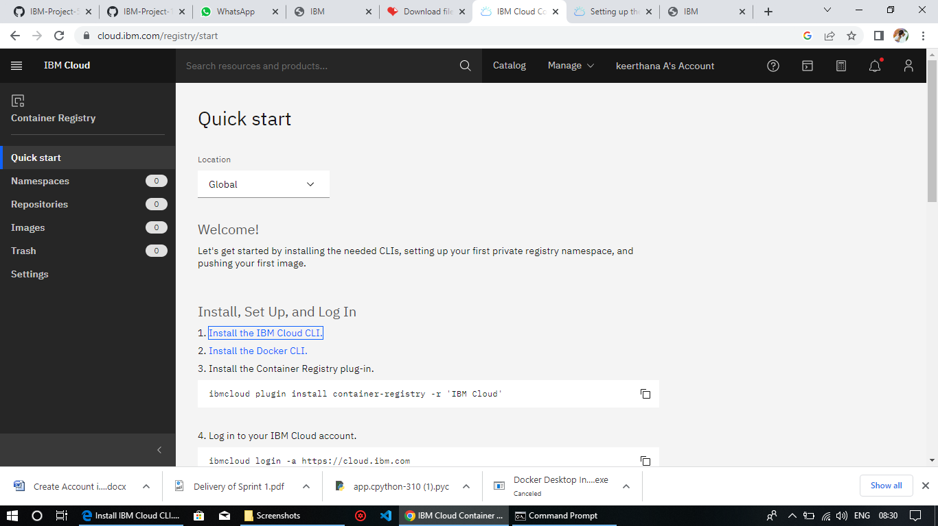

**Step 3:** In cloud CLI there is list of commands insert the into our windows command prompt

